**HelloWorld Servlet Program – StepbyStep Process**

**----------------------------------------------------------------------------------------------**

**Refer below link for installation of Apache Tomcat Server:**

<https://phoenixnap.com/kb/install-tomcat-ubuntu>. Later follow the below process for running servlet program.

Write index.html to display form with a submit button. Set the method attribute of the form to “get” to generate GET request to the server. Write a java servlet to display welcome message when the button is clicked. Write also the configuration file, namely, web.xml which maps the url mapped to the servlet class file.

Follow the directory structure for creating HelloServlet Web application and follow the guidelines below to configure and deploy web application.

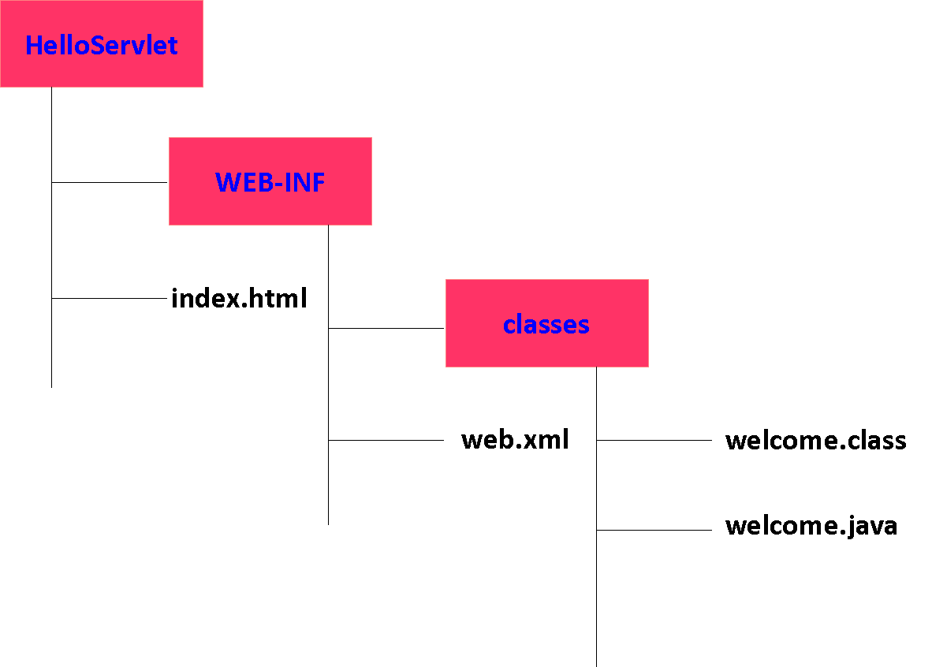

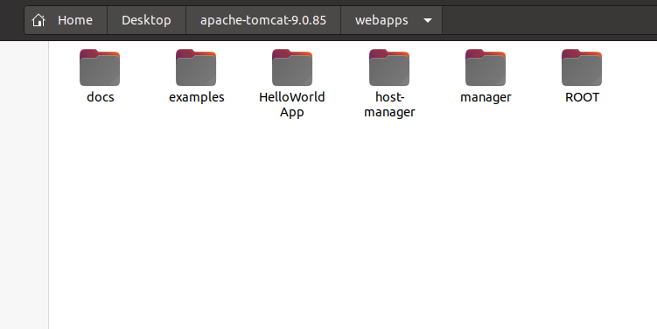

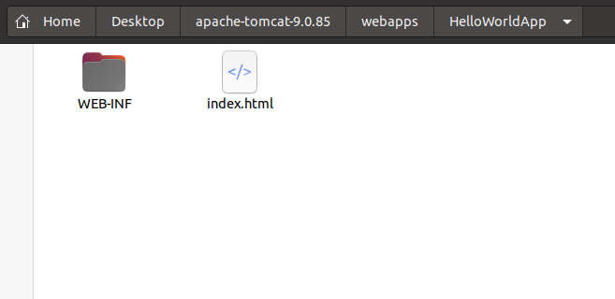

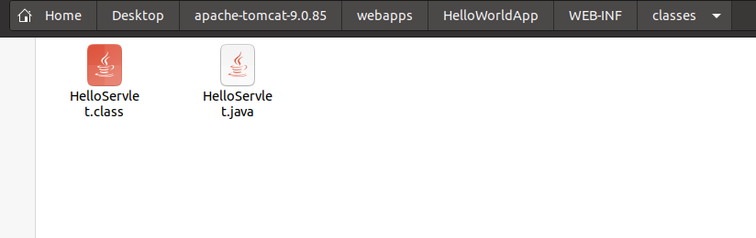

**index.html**

<html>

<head>

<title>My First Web Application</title>

</head>

<body>

<form action="hello" method="get">

<button type="submit">Click Me</button>

</form>

</body>

</html>

<web-app> 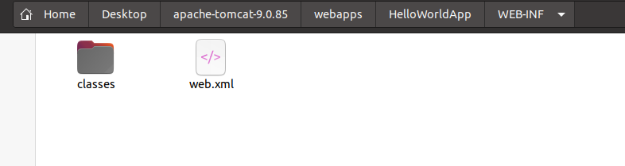

**web.xml**

<servlet>

<servlet-name>HelloServlet</servlet-name>

<servlet-class>HelloServlet</servlet-class>

</servlet>

<servlet-mapping>

<servlet-name>HelloServlet</servlet-name>

<url-pattern>/hello</url-pattern>

</servlet-mapping>

<welcome-file-list>

<welcome-file>index.html</welcome-file>

</welcome-file-list>

</web-app>

**HelloServlet.java**

import java.io.*;

import javax.servlet.*;

import javax.servlet.http.*;

public class HelloServlet extends HttpServlet {

public void doGet(HttpServletRequest request, HttpServletResponse response)

throws IOException, ServletException

{

response.setContentType("text/html");

PrintWriter out = response.getWriter();

out.println("<html>");

out.println("<head>");

out.println("<title>Hello World!</title>");

out.println("</head>");

out.println("<body>");

out.println("<h1>Hello World!</h1>");

out.println("</body>");

out.println("</html>");

}

}

HelloWorldApp Folder is created under webapps folder in Tomcat

In order to compile, java servlet, we need to store tomcat-servlet-api-9.0.4.jar under lib folder

**compile HelloWorld.java by using the following command:**

javac -classpath "/home/praba/Desktop/apache-tomcat-9.0.85/lib/tomcat-servlet-api-9.0.4.jar" HelloServlet.java

**Check whether Tomcat is running, it should show the following:**

In command prompt

$CATALINA_HOME/startup.sh

How do you see what is there in $CATALINA_HOME

echo ${CATALINA_HOME}

/home/Desktop/apache….

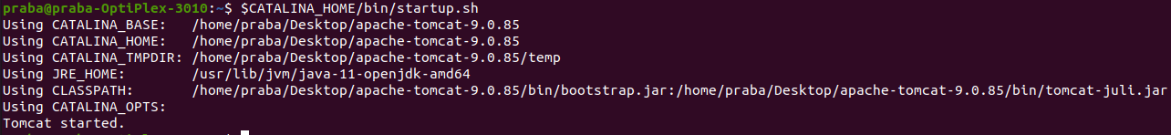

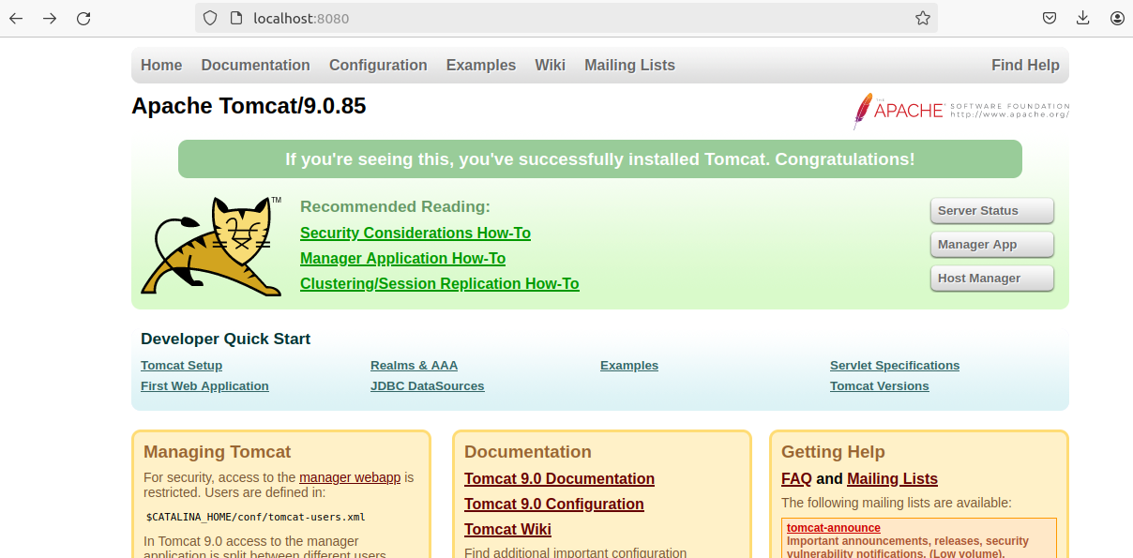

To run HelloWorldApp, navigate to the url : <http://localhost:8080/HelloWorldApp>

